Recommended Configurations for Survey Deployment
The survey system runs as a standard database driven web application. It is best hosted on a dedicated server running Linux, Apache and MySQL. These components have been chosen in order to reduce costs and simply licensing requirements. A dedicated server can be custom configured for each deployment quickly and cheaply.

In order to provide support during the setup and deployment phase of the survey it is recommended that InsightSRC have network access to the server. This access is via a SSH connection from specified IP addresses if the survey I hosted on a private network.

The server can indicate various error conditions via SMTP based email; in order for this to function it needs access external DNS and SMTP servers.

Below are two recommended configurations that simplify the deployment of the survey system without unduly compromising local network security.

Self Hosted

Private DMZ
This option places the server on the LAN or WAN behind their external firewall but in a Demilitarized Zone set up specifically for the survey (DMZ 2), separate from any other externally accessible servers run by the organisation (DMZ 1).

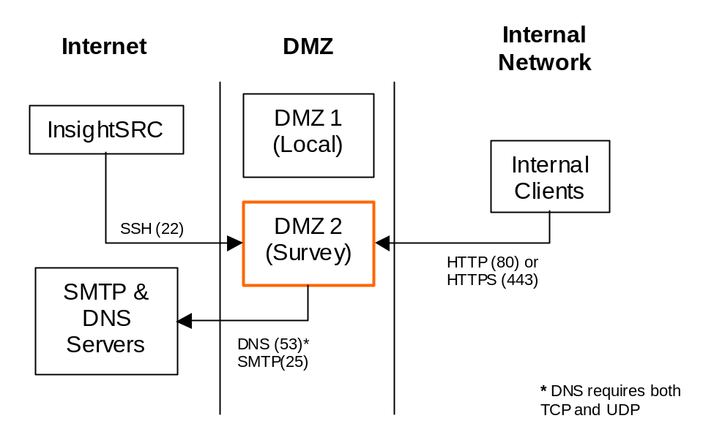

Notes
The server can also be made accessible from port 80 on the Internet side if remote personnel, who do not have dial up or VPN access to the local network, require access to the survey.

Advantages
- High speed access to the server for internal clients
- High availability access to the server for internal clients
- Secure access to the server by InsightSRC does not unduly compromise security

Disadvantages
- Requires firewall configuration by client
- Requires dedication of space and network access for duration or survey

Hosted Offsite
This option places the server on the public Internet. If required access can be limited to particular IP addresses, however password based security is usually enough and required for many applications of the survey system.
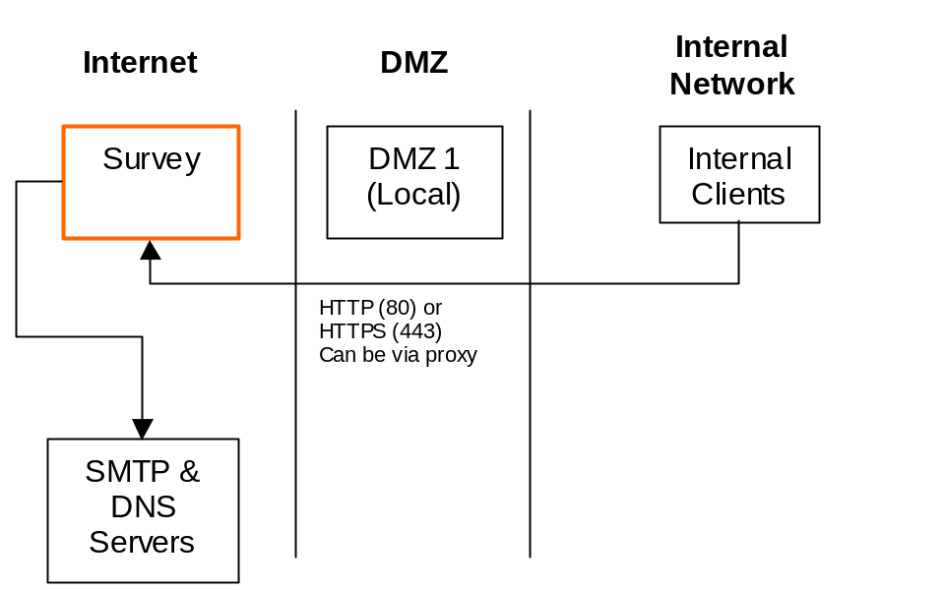

Advantages
- Simple configuration
- No access to network from external sources

Disadvantages
- Internet latency means slower response times
- Internet reliability means lower availability

